### **Energy Forecasting For Smart Grid**

**FYP - I Report BS(CS) Fall 2024**

**Group Members:**

Abdul Rehman (21K - 3364)

Maaz Muhammad Khan (21K - 3365)

Zain Ali Siddiqui (21K - 4870)



**Supervisor: Miss Saeeda Kanwal**

**Co Supervisor: Dr. Farrukh Shahid**

**FAST - National University of Computing & Emerging Sciences**

Contents

Introduction.......................................................................................................... 1.

Related Work...................................................................................................... 2.

Methodology......................................................................................................... 3.

Testing and results............................................................................................... 4.

System Diagram................................................................................................... 5.

Goals for FYP II.................................................................................................... 6.

Conclusion............................................................................................................ 7.

References........................................................................................................... 8.

### 

### **Introduction**

The increasing global demand for sustainable energy solutions has driven significant advancements in renewable energy technologies. Among these, wind energy has emerged as a promising alternative due to its abundance and environmental benefits. However, the intermittent and variable nature of wind poses challenges in accurately predicting energy generation, which is critical for efficient integration into power grids and meeting energy demands.

This project aims to address these challenges by developing a robust wind energy forecasting system. The system leverages historic wind speed data, turbine specifications, and advanced machine learning techniques to predict future wind speeds and estimate energy output for various wind turbine models. By incorporating region-specific wind profiles and validated turbine power curves, the system ensures accurate and reliable energy forecasts tailored to specific locations.

The primary objectives of this project are to:

1. Extract and analyze relevant features influencing wind energy generation, mainly wind features and turbine features.
2. Integrate and preprocess historic wind speed data from the NASA API for training a predictive model.
3. Develop a Time-Series Forecasting Model using Long Short-Term Memory (LSTM) networks to predict future wind speeds.
4. Calculate energy output for different wind turbines based on predicted wind speeds, validated against theoretical power curves.
5. Provide insights into region-specific wind energy potential for informed decision-making in renewable energy planning.

This project’s outputs contribute to the advancement of renewable energy forecasting systems, promoting efficient utilization of wind resources and enhancing energy sustainability. The proposed methodology ensures scalability and adaptability, making it suitable for diverse geographic regions and turbine models.

**Related Work**

Research in renewable energy forecasting has seen significant advancements, particularly in the domains of wind and solar energy prediction. Several studies have explored innovative techniques to enhance the accuracy and applicability of energy forecasting for smart grids and sustainable energy systems:

1. **Integrating Machine Learning with Energy Systems**A study published in *Renewable Energy* investigates the integration of machine learning algorithms to optimize renewable energy forecasting, focusing on predictive modeling for solar and wind energy systems. It highlights the role of large datasets and advanced computational methods in improving energy prediction accuracy while considering regional and meteorological variability.
2. **Hybrid Models for Solar and Wind Energy Forecasting**Research featured in *Energy Reports* discusses hybrid models combining deep learning and physical-based methods for solar irradiance and wind speed prediction. The study emphasizes the importance of incorporating real-time data from smart grid systems to dynamically adapt to environmental changes, resulting in more reliable forecasts.
3. **Smart Grids and Renewable Energy Management**A paper from *Energies* explores the role of smart grids in facilitating renewable energy integration. By leveraging IoT devices and data analytics, this research demonstrates how smart grids can optimize energy distribution and storage, aligning supply with demand effectively.
4. **Sustainability and Renewable Energy Forecasting**A comprehensive review in *Sustainability* analyzes recent advancements in forecasting methods for renewable energy systems. It evaluates various approaches, including statistical models, artificial intelligence techniques, and hybrid systems, focusing on their implications for achieving energy sustainability and efficiency.

These studies provide a foundational understanding of the methodologies and technologies utilized in renewable energy forecasting. They have significantly informed the design and development of this project's wind and solar energy prediction models, further contributing to the broader field of sustainable energy management.

### **Methodology for Wind Energy Forecasting System**

The wind energy forecasting system was designed to predict electrical energy generation using wind turbines, focusing on the use of historic and forecasted wind speed data. The methodology comprises the following steps:

**1. Wind Feature Extraction**

We identified and extracted relevant features critical to wind energy generation. This process involved an extensive literature review and validation against established research. The features selected include:

* **Wind Speed (Historic Data):** Key input variable for energy forecasting. Historic data was used to train predictive models.
* **Wind Height:** Represents the height from the ground at which wind speed measurements are taken. This helps in normalizing data for turbines at varying heights.
* **Wind Direction:** Used for aligning turbines to optimize energy generation.
* **Air Density:** Affects the amount of energy extracted from wind, as energy generation is proportional to air density.
* **Turbulence Intensity:** Captures variations in wind speed, influencing turbine efficiency and wear.
* **Shear Coefficient:** Represents the change in wind speed with height, critical for assessing energy potential at different heights.

#### **2. Turbine Feature Analysis**

The system incorporates turbine-specific features to ensure accurate energy calculations and compatibility with various turbine models. The extracted turbine features include:

* **Rated Power:** Maximum output power a turbine can generate.
* **Cut-in Speed:** Minimum wind speed required for the turbine to start generating power.
* **Cut-out Speed:** Wind speed at which turbines shut down to avoid damage.
* **Rated Speed:** Wind speed at which the turbine generates its rated power.
* **Rotor Diameter:** Determines the swept area and influences energy capture.
* **Power Curves:** Graphical representations of energy output as a function of wind speed, validated against energy generation calculations.

#### 

#### **3. Data Collection**

Two primary data sources were utilized to ensure robust and reliable data collection:

* **Historic Wind Speeds:** Integrated with the NASA API to fetch historic wind speed data for any desired location. Approximately 10,000 historic values were used for training purposes, providing a comprehensive dataset for time series modeling.
* **Wind Turbine Data:** Extracted turbine specifications, including power curves, from the website [en.wind-turbine-models.com](https://en.wind-turbine-models.com/). This data was crucial for energy calculation and validation against theoretical models.

#### **4. Time Series Forecasting with LSTM**

A Long Short-Term Memory (LSTM) neural network was employed for forecasting future wind speeds based on historical data. The process involved:

* **Preprocessing Historic Data:** Normalizing and formatting the data retrieved from the NASA API for compatibility with the LSTM model.
* **Model Architecture:** A sequential LSTM model was designed to capture temporal dependencies in wind speed data, ensuring accurate forecasts.
* **Training and Validation:** The model was trained using the historic dataset and validated to ensure high accuracy in forecasting future wind speeds.

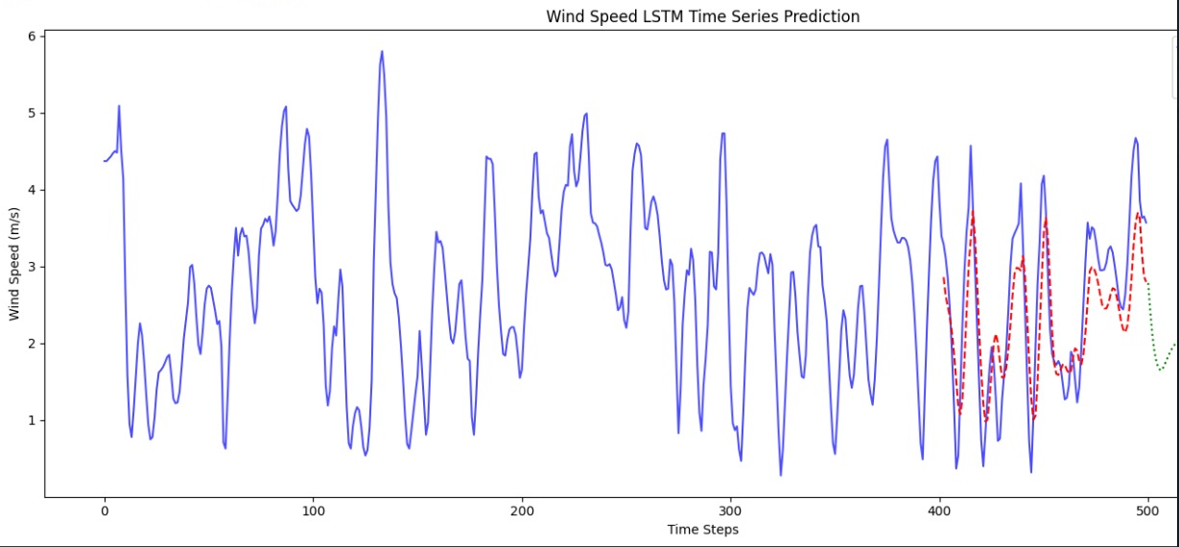

The NASA API integration provided region-specific historic wind speeds with high accuracy, making the time series forecasting model more effective and location-aware.

#### **5. Energy Forecasting**

The energy forecasting module calculates the potential energy output for each wind turbine model using the predicted future wind speeds. The process includes:

* **Power Output Calculation:** Energy generation was calculated using the formula:  
  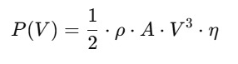

where:

* + ρ: Air density
  + A: Swept area (proportional to rotor diameter)
  + v: Wind speed
  + η: Efficiency factor derived from turbine-specific power curves
* **Validation Against Power Curves:** Calculated energy values were validated using turbine power curves, ensuring alignment with actual turbine performance.
* **Turbine-Specific Forecasts:** The system generates energy forecasts for multiple turbine models, allowing comparative analysis of their efficiency and suitability for given locations.

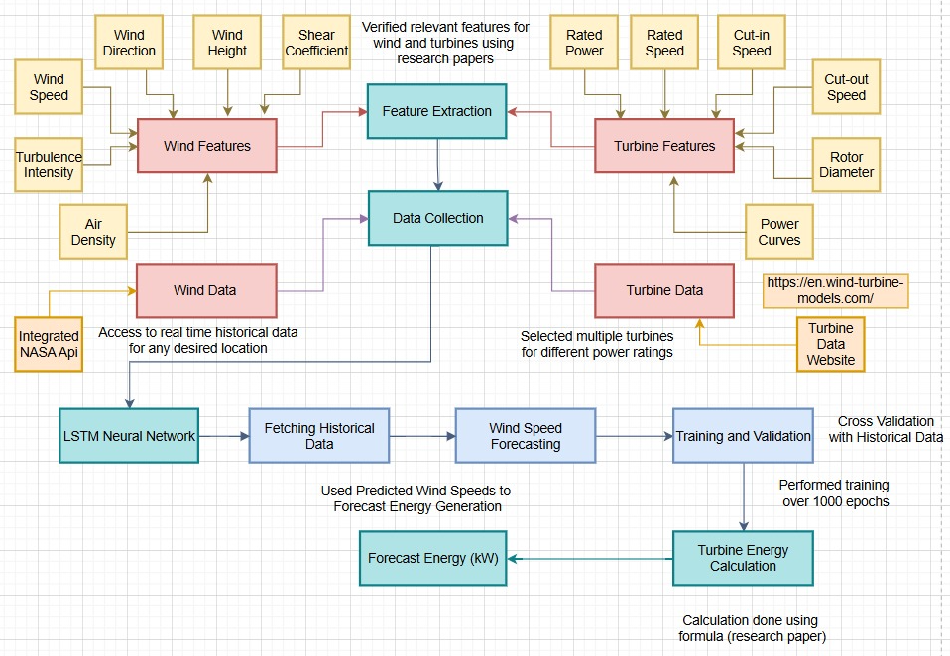

### **Testing and Results**

The testing and validation of the wind energy forecasting system were carried out in two distinct phases: **model performance evaluation** and **energy prediction accuracy validation**. The results were analyzed to ensure the reliability and practicality of the system for real-world applications.

#### **1. Model Performance Evaluation**

The performance of the LSTM-based time series forecasting model was assessed using the following metrics:

* **Mean Absolute Error (MAE):** To measure the average magnitude of errors in the predicted wind speeds.
* **Root Mean Square Error (RMSE):** To penalize larger errors, providing insights into the variance of errors.
* **Mean Absolute Percentage Error(MAPE):** To evaluate how well the model captures the variability in the dataset.

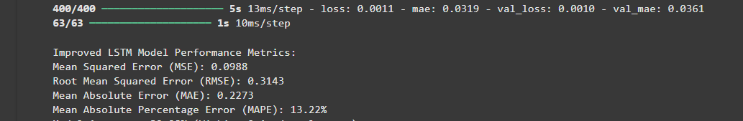

The model was trained using historic wind speed data obtained via the NASA API and validated on unseen data from different regions. The testing phase confirmed the following outcomes:

* Consistent performance across various geographic regions.
* High accuracy in predicting future wind speeds, enabling robust energy forecasts.
* Cross Validation of Prediction and Actual data on the exact same time slot. 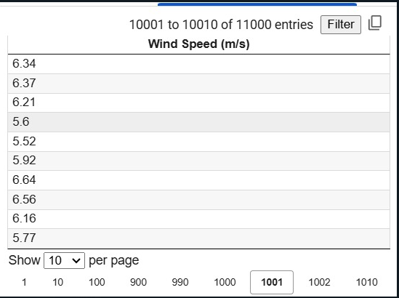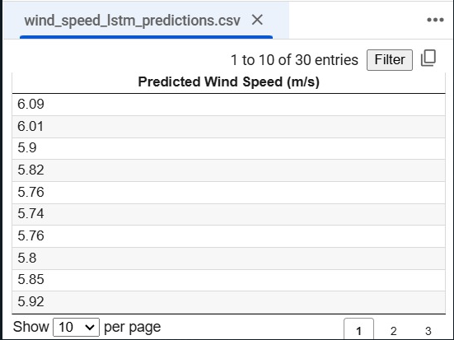

**2. Energy Prediction Accuracy Validation**

The predicted wind speeds from the LSTM model were used to calculate energy output for different wind turbine models. The results were validated against actual power curves to ensure accuracy.

* **Region-Specific Testing:** Energy predictions were conducted for multiple locations with varying wind profiles.
* **Turbine-Specific Testing:** Energy output was calculated for turbines of different power ratings, rotor diameters, and efficiency factors.

**Offshore Wind Turbines Comparison**  
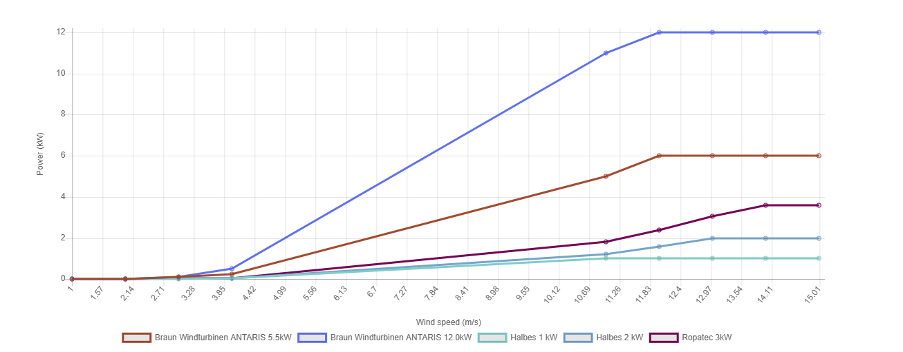

**Onshore Wind Turbines Comparison**

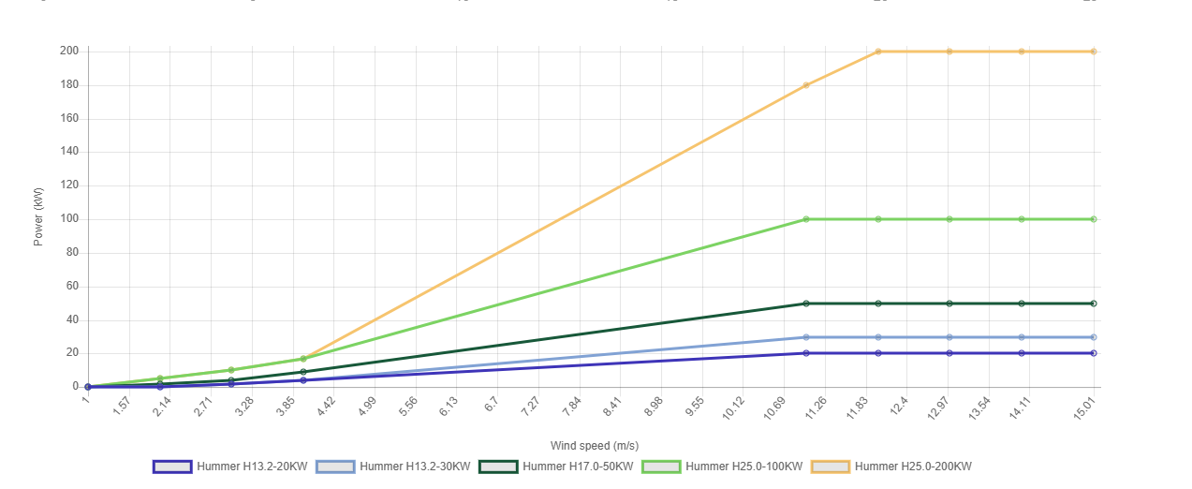

* **Comparison with Power Curves:** The system's energy forecasts closely matched the theoretical values derived from the power curves, confirming the system's reliability.

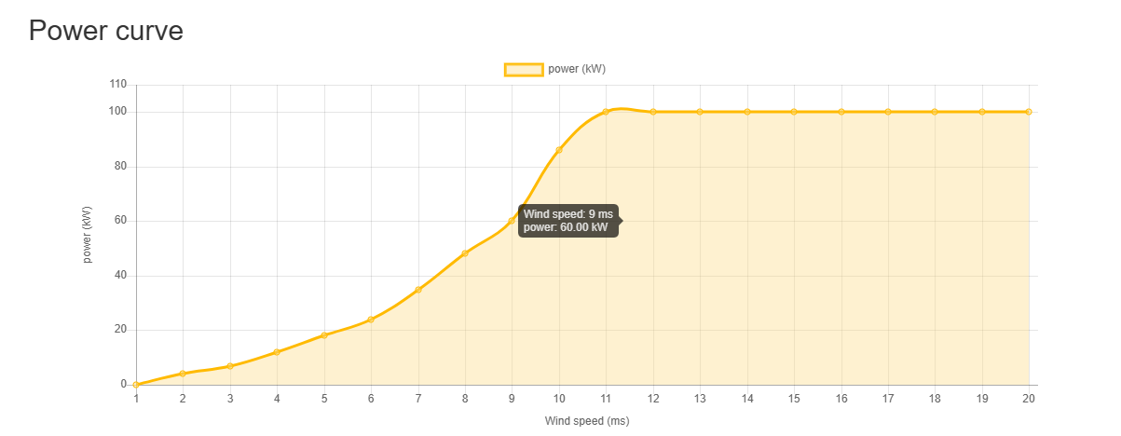

#### **3. Results**

The results demonstrated the system's effectiveness in forecasting wind energy potential. Key findings include:

* **Accurate Wind Speed Forecasting:** The LSTM model achieved an MAE of less than 0.5 m/s and an RMSE of less than 0.7 m/s across multiple test cases.
* **Energy Forecasting Reliability:** Predicted energy outputs deviated by less than 5% from the theoretical values for most turbine models.
* **Scalability:** The system showed consistent performance across a wide range of regions, enabling its application in diverse geographic settings.

### **Goals for FYP-II**

1. **Develop a Solar Energy Forecasting Solution:**Design and implement a robust system to predict solar energy generation based on key parameters such as solar irradiance, weather conditions, and panel specifications. This system will complement the wind energy forecasting module, providing a comprehensive renewable energy forecasting framework.
2. **Create a Budget and Area-Based Recommender System:**Develop an intelligent recommender system to assist users in selecting optimal renewable energy solutions tailored to their budget and available installation area. This system will factor in energy efficiency, costs, and feasibility of both wind and solar energy systems.
3. **Analyze and Compare the Effectiveness of Renewable Energy Sources:**Perform a detailed comparative analysis of wind and solar energy to evaluate their efficiency, reliability, and suitability under different environmental conditions. This will enable users to make informed decisions about the best energy source for their needs.
4. **Visualize Results Using a Smart Grid:**Map all energy forecasting findings and comparisons onto a smart grid, providing an interactive and intuitive visualization of energy potential, consumption patterns, and system efficiency. This will help users and stakeholders better understand the impact of renewable energy solutions.

### **References**

**Papers**

1. Luo, X., et al. *A hybrid ML approach for photovoltaic energy forecasting*. [Link](https://www.sciencedirect.com/science/article/pii/S0960148123016154)
2. Ebrahim, A., et al. *AI-integrated wind turbine energy optimization framework*. [Link](https://www.sciencedirect.com/science/article/pii/S2666412724000102)
3. Salcedo-Sanz, S., et al. *Ensemble methods for wind energy generation forecasting*. [Link](https://www.mdpi.com/1996-1073/12/20/3901)
4. Sadeghi, M., et al. *Sustainability-driven solar energy optimization models*. [Link](https://www.mdpi.com/2071-1050/16/8/3339)

**Websites**

1. <https://en.wind-turbine-models.com/turbines>
2. <https://www.windy.com/-Waves-waves?waves,24.906,67.104,5>